Table of Contents
- Introduction
1.1 Purpose
1.2 Intended Audience and Reading Suggestions
1.3 Project Scope
1.4 Reference
- Overall Description
2.1 Product Perspective
2.2 Product Features
2.3 User Classes and Characteristics
2.4 Operating Environment
2.5 Assumptions and Dependencies
- System Features
3.1 Inventory Management
3.2 Shipment Tracking
3.3 Role-Based Access Control (RBAC)
3.4 Historical Data Search
3.5 Admin Dashboard
- External Interface Requirements
4.1 User Interfaces
4.2 Hardware Interfaces
4.3 Software Interfaces
4.4 Communications Interfaces
- Other Nonfunctional Requirements
5.1 Security Requirements
5.2 Software Quality Attributes
5.2.1 Correctness
5.2.2 Availability
5.2.3 Security
5.2.4 Portability
5.2.5 Performance
- Supporting Information
6.1 Development Phases
6.2 Test Cases
6.4 Team Contributions
- Installation/Usage
7.1 Installation
7.2 User Manual
- Code Inspection Feedback
- Reflection

Revision History:

Name | Date | Reason For Changes | Version
Initial | 9/21/2025 | … | 1
Y.B., D.B., & J.H., C.N.A. | 11/16/2025 | * Significant overhaul of requirements to reflect updated system design and user roles.  * Updated UI screenshots for modern design.  * Replaced Client user class with Manager; updated requirements throughout to match actual user roles.  * Consolidated packing slip functionality into Shipment Tracking (Section 3.2) and removed Section 3.3.  * Adjusted all related test cases, installation instructions, and usage documentation to reflect these changes. | 1.1

- Introduction

1.1 Purpose:
The Inventory & Shipment Management Portal is designed to help engineering teams and managers track incoming materials and packing slips before deployment. Its main goal is to ensure that all required components have been received, documented, and confirmed before on-site installation. By providing secure access, real-time updates, and centralized documentation, the app improves communication, reduces delays, and builds trust with managers, since the manager is purchasing these items. This system acts as a shared workspace where both engineers and managers can stay aligned and confident throughout the deployment process.

1.2 Intended Audience and Reading Suggestions
This document is intended for developers of the app, so they may appropriately and completely implement features, and for stakeholders of the app, so that they may be in the loop as to what exactly will be implemented. Should there be questions as to an implementation/feature, the developer or stakeholder should reference this document and then contact the party who may have an answer should this document fail to do so.

1.3 Project Scope
This document outlines the requirements for Flowventory, a web-based portal designed to help engineering teams and managers manage incoming shipments and inventory before deployment. It is intended for developers, who will use it to implement system features accurately, and stakeholders, who need visibility into what the system will deliver. Flowventory allows managers to submit and track orders, view documentation, and monitor inventory status, while engineers can upload packing slips, tag items by urgency or vendor, and confirm readiness for installation. Admins have access to product management, user roles, and audit logs. The system focuses on pre-deployment coordination and transparency, and does not support outbound logistics or direct purchasing.

1.4 Reference
IEEE 830-1993 Recommended Practice for Software Requirements Specification
Cin7 Inventory Management Review:
https://www.business.org/finance/inventory-management/cin7-review/
- Overall Description
Flowventory is a standalone web-based portal designed to help engineering teams and managers manage incoming inventory and shipments before deployment. It supports the tracking of ordered materials, documentation upload, such as packing slips. Real-time visibility into inventory status. The system includes detailed permission controls through role-based accounts (Manager, Engineer, Admin), and maintains a searchable record of previously received items, quantities, and associated documentation. Flowventory streamlines communication between stakeholders and ensures deployment readiness by confirming that all required components have been received and documented before installation begins.
2.1 Product Perspective
This product is being built for web access, primarily targeting a 1920x1080 display, with the ability to be tested against different aspect ratios, including common mobile devices, if time allows. It will utilize a SQL database and Python for the backend, and HTML/CSS/JS for the frontend and web display.

2.2 Product Features
Flowventory’s core functionality centers around inventory and shipment management for engineering deployments. Users can add items to the system, monitor their status, and track usage over time. The platform supports ordering replacements, uploading and viewing packing slips, and tracking shipments from vendors. Historical data is stored and searchable, allowing users to review past orders, quantities, and documentation. Role-based access ensures that managers, engineers, and admins each have tailored views and permissions, supporting secure collaboration and deployment readiness.
2.3 User Classes and Characteristics
Flowventory is designed to support three primary user classes, each with distinct roles, access levels, and usage patterns:

1. Admin
- Use the system frequently to manage users, roles, and product data
- Access all system features, including audit logs and configuration settings
- Full access to all modules: Dashboard, Stock, Pick, Shipments, Inventory, Orders, and Admin Panel
- Require robust controls for security, oversight, and troubleshooting
- Prioritized for maintaining system integrity and operational continuity
2. Manager
- Use the system regularly to fill out packing slip forms and manage inventory
- View shipments in the shipments table to track all deliveries
- Filter and tag shipments by urgency, vendor, or project
- Manage inventory items (add, edit, delete) and shipment records
- Access to: Dashboard, Stock, Pick, Shipments, Inventory, Orders
- No access to Admin panel or user management
- Comfortable with technical workflows and documentation standards
- Prioritized for accuracy and efficiency in preparing deployments
3. Engineer
- Use the system regularly to create packing slips by filling out shipment forms to track who is delivering items and where
- View shipments table to monitor all shipment records
- Perform pick operations from warehouse inventory
- Filter and tag shipments by urgency, vendor, or project
- Access to: Dashboard, Stock, Pick, Shipments, Inventory
- No access to Admin panel or user management
- Comfortable with technical workflows and documentation standards
- Prioritized for accuracy and efficiency in warehouse operations

2.4 Operating Environment
Flowventory is a web-based application designed to run on modern desktop and mobile browsers. The frontend is built using HTML, JavaScript, and CSS, with support for Next.js where needed to enable server-side rendering and routing. The backend is developed in Python using FastAPI, with PostgreSQL as the primary database management system. The system is containerized using Docker to ensure consistent deployment across environments. Cloudflare is implemented to manage secure access, DNS configuration, and performance optimization. Flowventory is compatible with major operating systems, including Windows, macOS, and supports browsers such as Chrome, Firefox, Edge, and Safari.

2.5 Assumptions and Dependencies
Flowventory assumes users will access the system through modern browsers on up-to-date operating systems (Windows, macOS, iOS, Android). The development team is expected to work within a defined tech stack: HTML, CSS, JavaScript (with optional Next.js), Python with FastAPI, and PostgreSQL. The system depends on Docker for containerization, Nginxfor reverse proxy management, and Cloudflare for secure access and DNS routing. Hosting is assumed to be available through platforms like AWS. Any changes to these technologies or hosting availability may impact development, deployment, or system performance.

3. System Features
3.1 Inventory Management
The inventory management feature exists to maintain a clear record of all received materials. It allows users to add items, track status, and prepare materials for deployment readiness across all warehouse locations.
- REQ-INV-1: The system shall allow users (Admin, Manager, Engineer) to add inventory items manually through a form interface.
- REQ-INV-2: The system shall record comprehensive item details, including: Item ID, SKU, Description, Vendor, Quantity, Zone, Aisle, Rack, Shelf, Bin, Storage Location (auto-generated), Category, Weight, Dimensions, Barcode, and Status.
- REQ-INV-3: The system shall allow users to update the status of items (pending_inspection, ready_for_deployment, in_transit, deployed, returned).
- REQ-INV-4: The system shall allow filtering/searching of inventory by Item ID, SKU, Barcode, Vendor, Status, or Storage Location.
- REQ-INV-5: The system shall allow editing and deletion of inventory items. Admins and Managers have full edit/delete permissions; Engineers have view and update permissions.
- REQ-INV-6: If duplicate Item IDs or Barcodes are entered, the system shall return an error message and require correction before saving.
- REQ-INV-7: The system shall auto-generate storage location strings in the format: Zone-Aisle-Rack-Shelf-Bin (e.g., A-A1-R01-S2-BIN-003).
- REQ-INV-8: The system shall display inventory items in a paginated table view (10 items per page) with sortable columns.
3.2 Shipping Tracking
Shipment tracking allows both engineers and managers to log and monitor incoming shipments from vendors, ensuring that all expected materials are accounted for before deployment. This feature now includes verified documentation of received shipments via packing slips. Engineers and managers can create shipment entries and attach packing slips directly through forms, streamlining workflows and maintaining a complete record of received items.
- REQ-SH-1: The system shall allow manual entry of shipment details, including “tracking” order number (if available), vendor, carrier, expected delivery date, and contents.
- REQ-SH-2: The system shall allow engineers to mark shipments as received or partially received.
- REQ-SH-3: The system shall allow engineers and managers to attach packing slips via forms for each shipment.
- REQ-SH-4: Each packing slip shall be linked to a shipment and/or inventory record.
- REQ-SH-5: The system shall allow tagging of shipments and packing slips by vendor or urgency.
- REQ-SH-6: Managers shall have read-only access to packing slips uploaded by engineers but may edit or delete their own uploads.
- REQ-SH-7: If a shipment is marked partially received, the system shall flag missing items for follow-up.
- REQ-SH-8: The system shall maintain a version history for packing slips if they are replaced or updated.
3.3 Packing Slip Creation (Form-Based Entry)
Packing slip creation provides a structured way for Engineers and Managers to document outbound and inbound shipments by filling out detailed shipment forms rather than uploading files.
- REQ-PS-1: The system shall provide a form interface for creating packing slips with fields for all shipment details (invoice info, shipping details, item details, carrier information).
- REQ-PS-2: Each packing slip (shipment record) shall be stored in the database and displayed in the shipments table.
- REQ-PS-3: The system shall allow both Engineers and Managers to create packing slips through the form interface.
- REQ-PS-4: The system shall allow tagging and categorization of packing slips by vendor, urgency, project, or item type.
- REQ-PS-5: Managers and Admins shall have full edit and delete permissions for shipment records; Engineers can create and view shipments.
- REQ-PS-6: The system shall require all mandatory fields (Invoice Number, Ship Via, Quantity) to be filled before allowing form submission.
- REQ-PS-7: The system shall display all created packing slips in the shipments table with filtering and search capabilities.
3.4 Pick Operations
Pick operations allow users to search for inventory items, view their warehouse locations, and reduce quantities when items are picked for deployment or shipment.
- REQ-PICK-1: The system shall allow searching for items by Item ID, SKU, or Barcode through a search interface.
- REQ-PICK-2: The system shall display complete item details when found, including current quantity and exact warehouse location (Zone, Aisle, Rack, Shelf, Bin).
- REQ-PICK-3: The system shall allow users to specify a pick quantity and update the inventory accordingly.
- REQ-PICK-4: The system shall validate that pick quantity does not exceed available quantity and display an error if it does.
- REQ-PICK-5: The system shall automatically calculate and update remaining quantity after successful pick operations (Remaining = Current - Picked).
- REQ-PICK-6: The system shall display warehouse location information clearly to guide users to the physical item location.
- REQ-PICK-7: All roles (Admin, Manager, Engineer) shall have full access to pick operations.
3.5 Stock Management
Stock management allows users to add new items to warehouse inventory, specify warehouse locations, and track incoming stock deliveries.
- REQ-STOCK-1: The system shall provide a form interface for adding new stock items with complete details (Item ID, Description, Quantity, Vendor, Warehouse Location).
- REQ-STOCK-2: The system shall allow specification of warehouse location components (Zone, Aisle, Rack, Shelf, Bin).
- REQ-STOCK-3: The system shall auto-generate the complete storage location string from location components.
- REQ-STOCK-4: The system shall validate that all required fields are filled before allowing stock entry.
- REQ-STOCK-5: The system shall prevent duplicate Item IDs and Barcodes during stock entry.
- REQ-STOCK-6: All roles (Admin, Manager, Engineer) shall have full access to stock management features.
- REQ-STOCK-7: The system shall allow bulk stock entry and updates for efficiency.
3.6 Role-Based Access Control (RBAC)
RBAC ensures data integrity and security by limiting system access according to user roles: Admin, Manager, and Engineer.
- REQ-RBAC-1: The system shall define three user roles with hierarchical permissions: Admin (full access), Manager (elevated access), and Engineer (standard access).
- REQ-RBAC-2: Engineers shall have permissions to: create packing slips, perform pick operations, add stock, view inventory, view shipments table, and update inventory quantities.
- REQ-RBAC-3: Managers shall have all Engineer permissions plus: full inventory management (add, edit, delete), full shipment management, and filter/tag capabilities.
- REQ-RBAC-4: Admins shall have full system access, including user management, role assignment, audit logs, and system configuration.
- REQ-RBAC-5: The Admin panel shall be accessible only to users with the Admin role; all other roles shall receive "Access Denied" message.
- REQ-RBAC-6: Unauthorized actions shall return an "Access Denied" error message and prevent the operation.
- REQ-RBAC-7: The system shall log all user actions for audit purposes (future implementation).
3.7 Dashboard and Metrics
The dashboard provides an overview of system status, key metrics, and quick access to common operations.
- REQ-DASH-1: The dashboard shall display key metrics including: Total Inventory Count, Active Shipments, Warehouse Zones in Use, and Recent Activity.
- REQ-DASH-2: The dashboard shall provide quick action buttons for: Stock Parts, Pick Items, Create Shipment, and View Inventory.
- REQ-DASH-3: The dashboard shall display role-appropriate content based on user permissions.
- REQ-DASH-4: All roles shall have access to view the dashboard with metrics relevant to their permissions.
- REQ-DASH-5: The dashboard shall refresh data automatically when users navigate back to it.
3.8 User Management (Admin Only)
The user management feature provides Admins with tools to create, edit, and manage user accounts and permissions.
- REQ-USER-1: The system shall allow Admins to create new user accounts with auto-generated usernames and secure random passwords.
- REQ-USER-2: The system shall allow Admins to assign roles (Admin, Manager, Engineer) and specify assigned pages for each user.
- REQ-USER-3: The system shall display all users in a paginated table with user details, role badges, and action buttons.
- REQ-USER-4: The system shall allow Admins to edit user details (name, role, assigned pages) but prevent username changes.
- REQ-USER-5: The system shall allow Admins to delete user accounts with confirmation prompts.
- REQ-USER-6: The system shall enforce unique usernames and display errors for duplicate entries.
- REQ-USER-7: Passwords shall be securely hashed before storage in the database.
- REQ-USER-8: Only users with Admin role shall have access to user management features.
3.9 Search and Filtering
Search and filtering capabilities allow users to quickly locate inventory items, shipments, and records across the system.
- REQ-SEARCH-1: The system shall provide search functionality on Inventory page by Item ID, SKU, Description, Vendor, or Barcode.
- REQ-SEARCH-2: The system shall provide search functionality on Shipments page by Invoice Number, Vendor, Ship Via, or Item Type.
- REQ-SEARCH-3: The system shall allow filtering by status (for inventory) and date ranges (for shipments).
- REQ-SEARCH-4: Search results shall display in real-time as users type in search fields.
- REQ-SEARCH-5: The system shall display a "No results found" message when searches return no matches.
- REQ-SEARCH-6: The system shall allow clearing search filters to return to full list view.

4. External Interface Requirements
4.1 User Interfaces
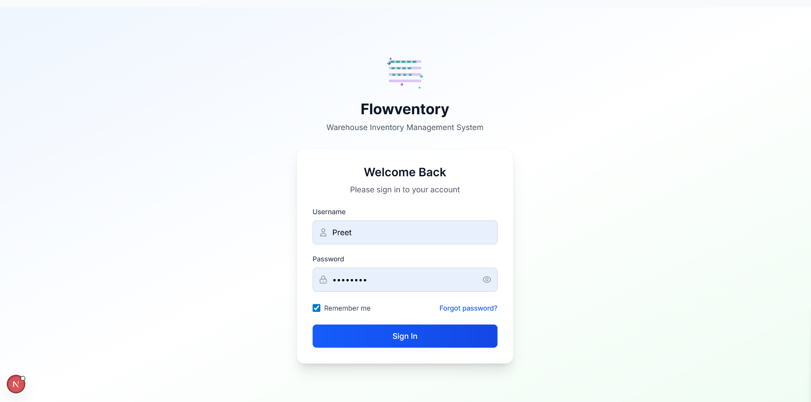
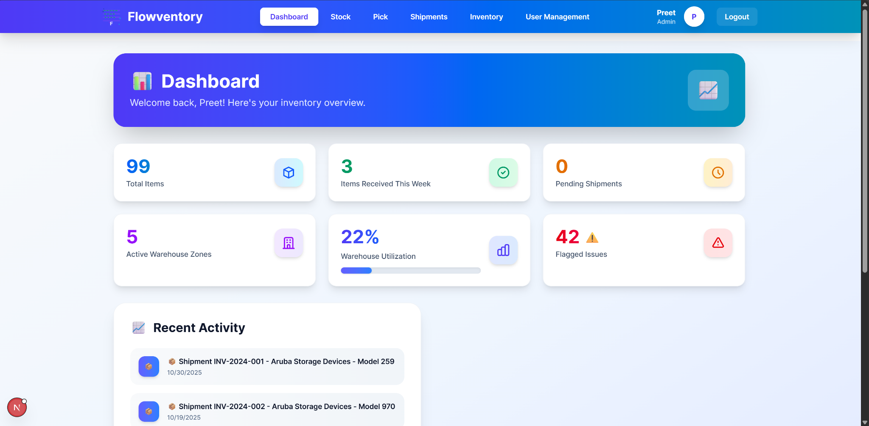
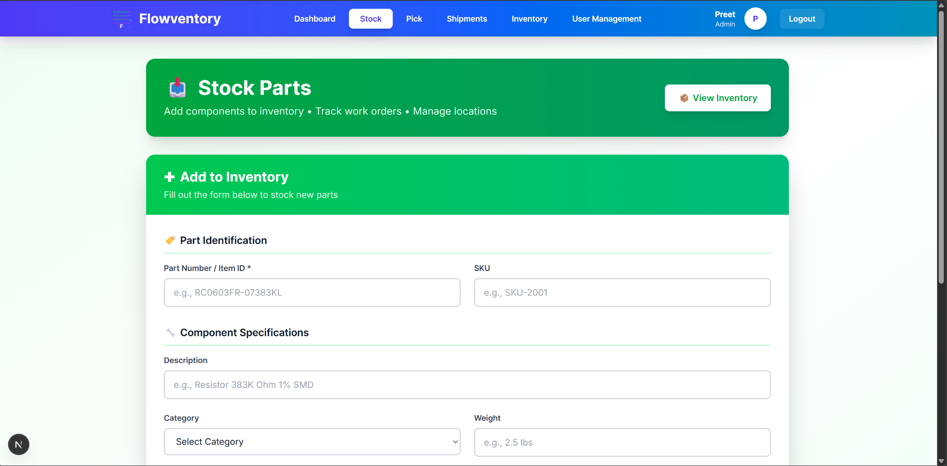
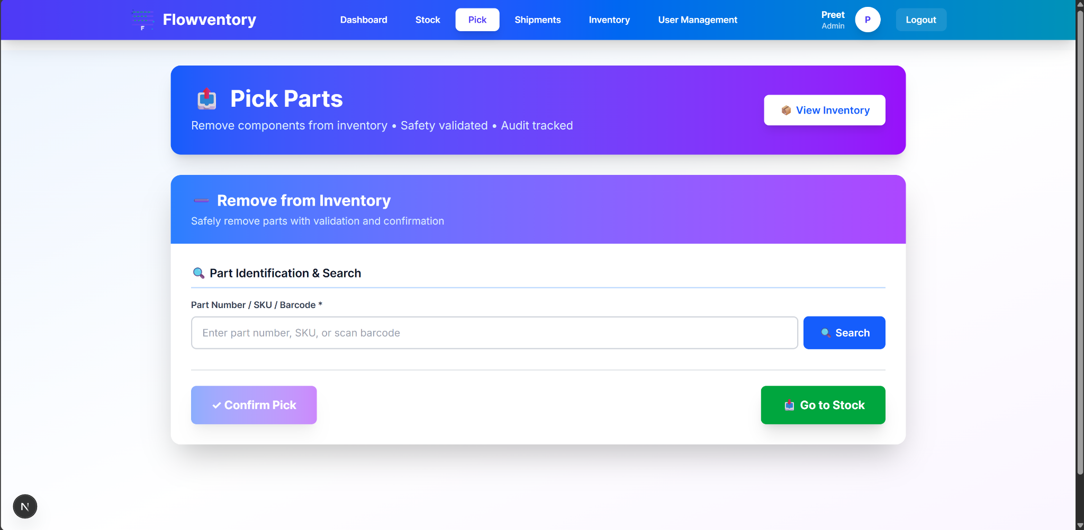
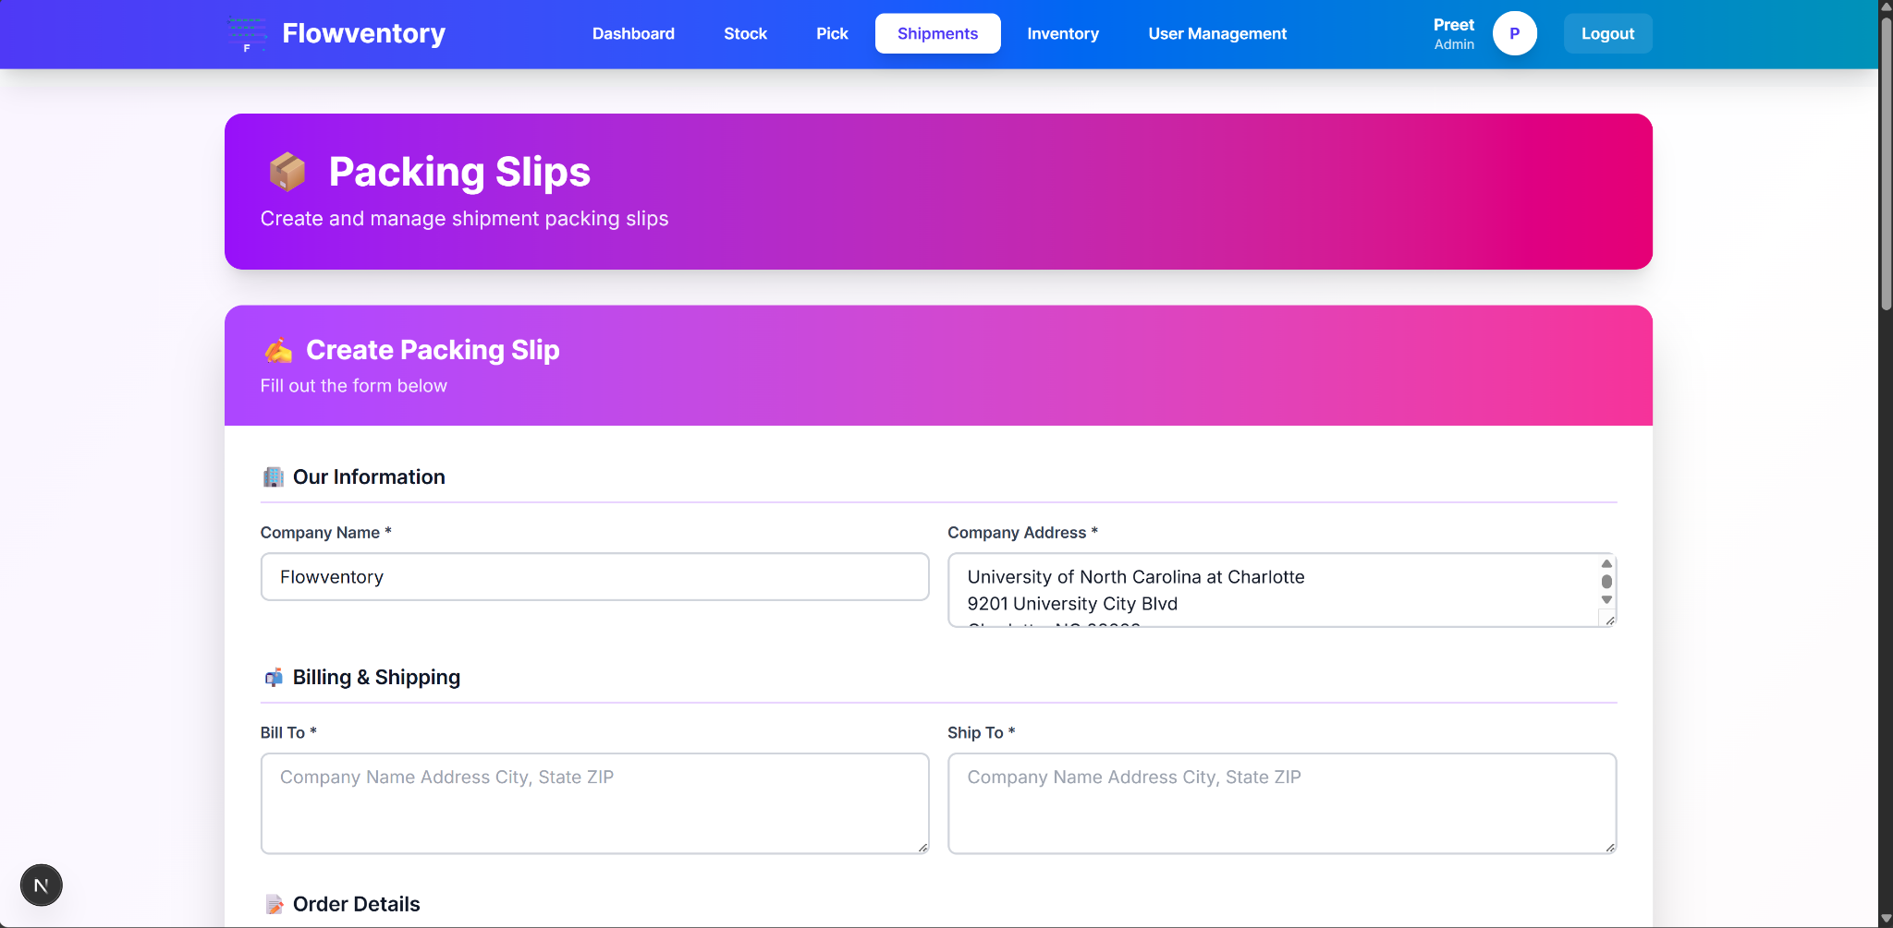
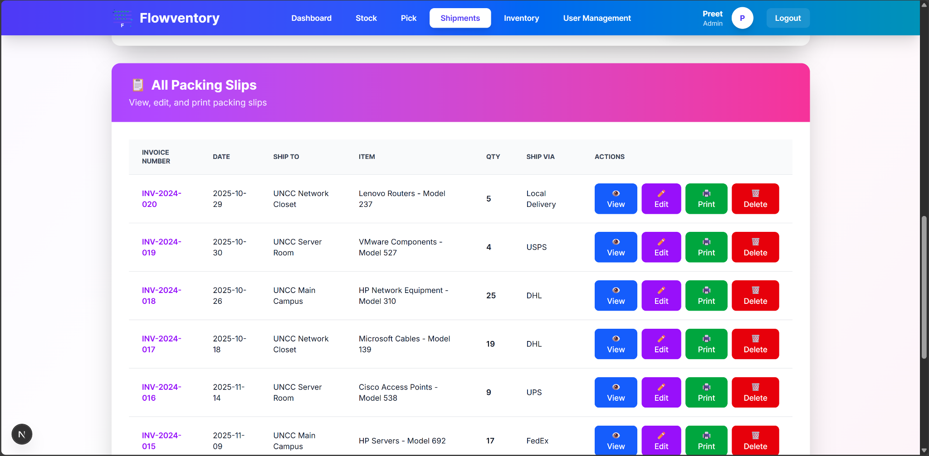
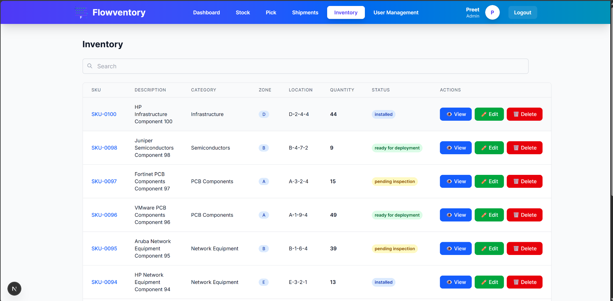
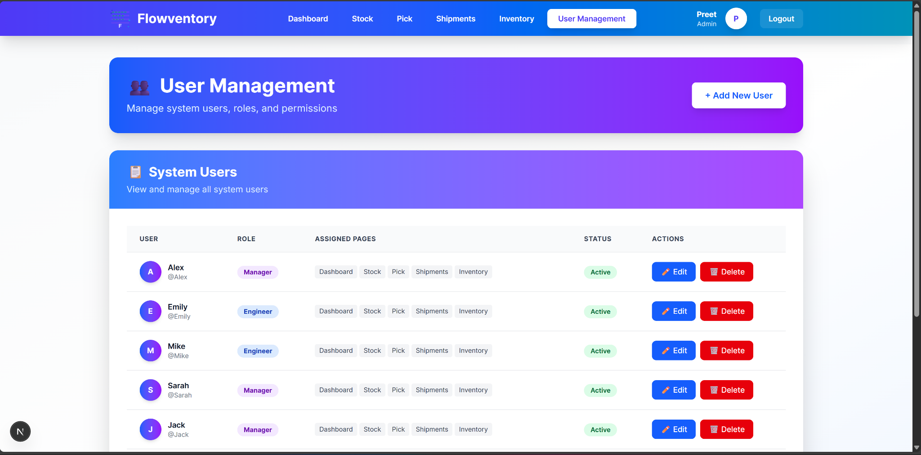
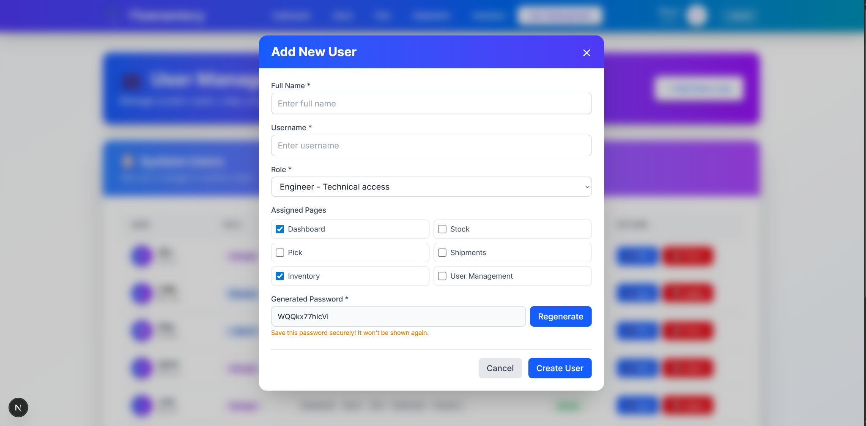
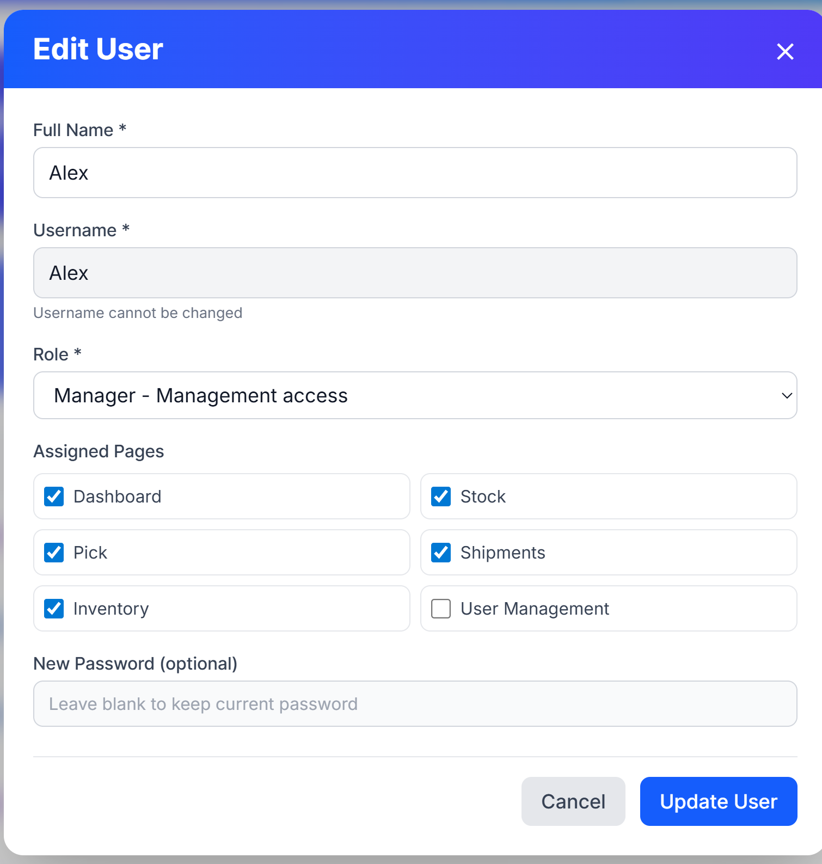
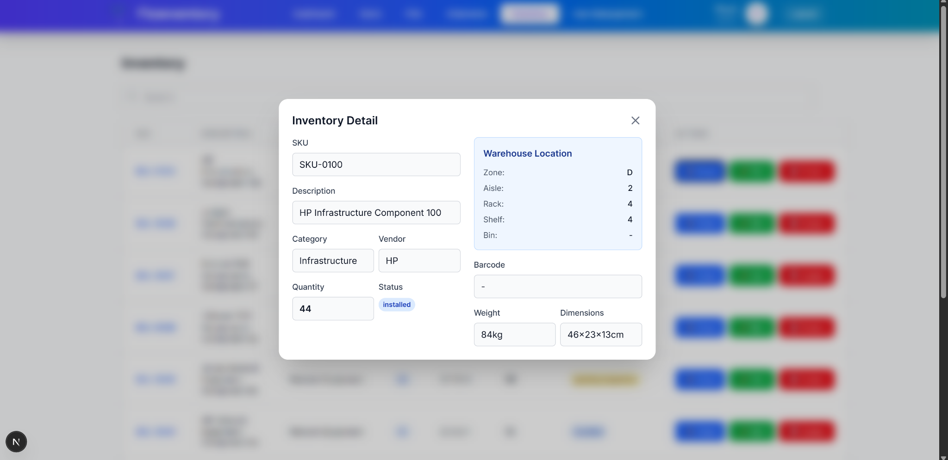
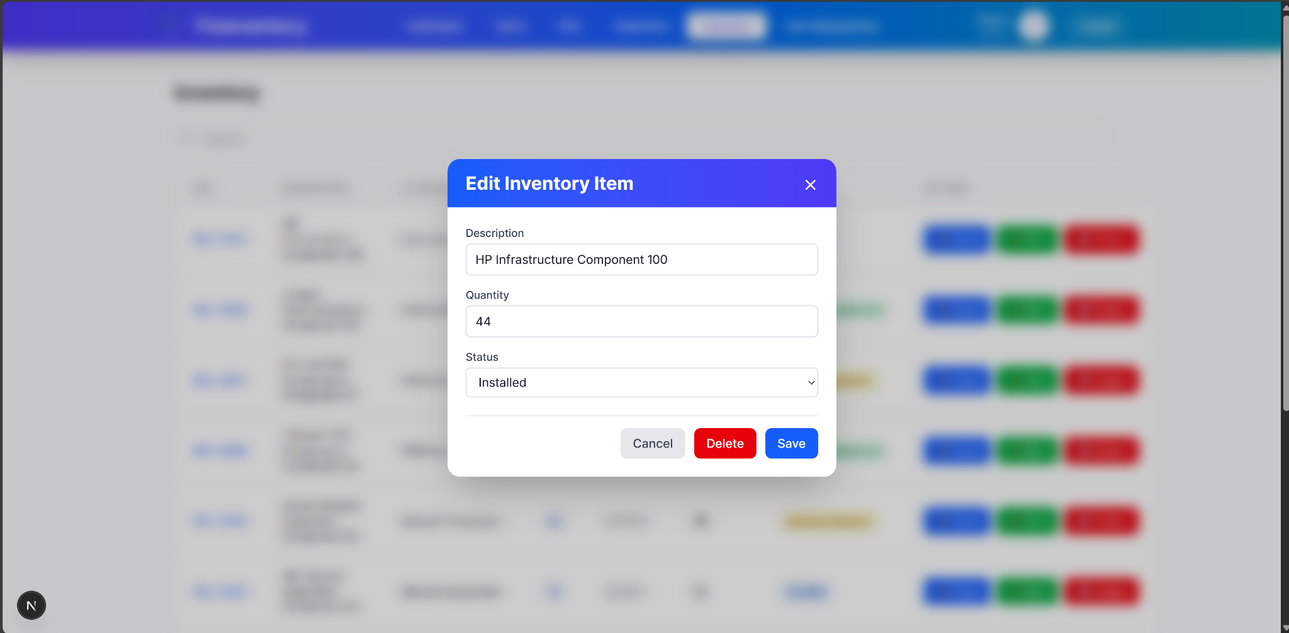

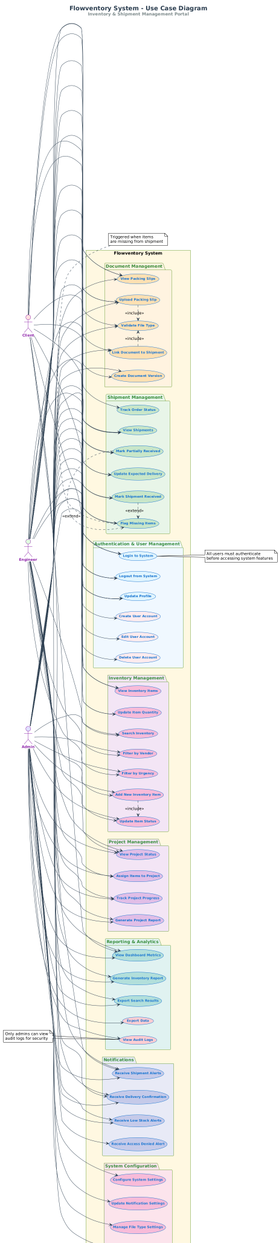

4.2 Hardware Interfaces
No specific hardware interfaces required.
4.3 Software Interfaces
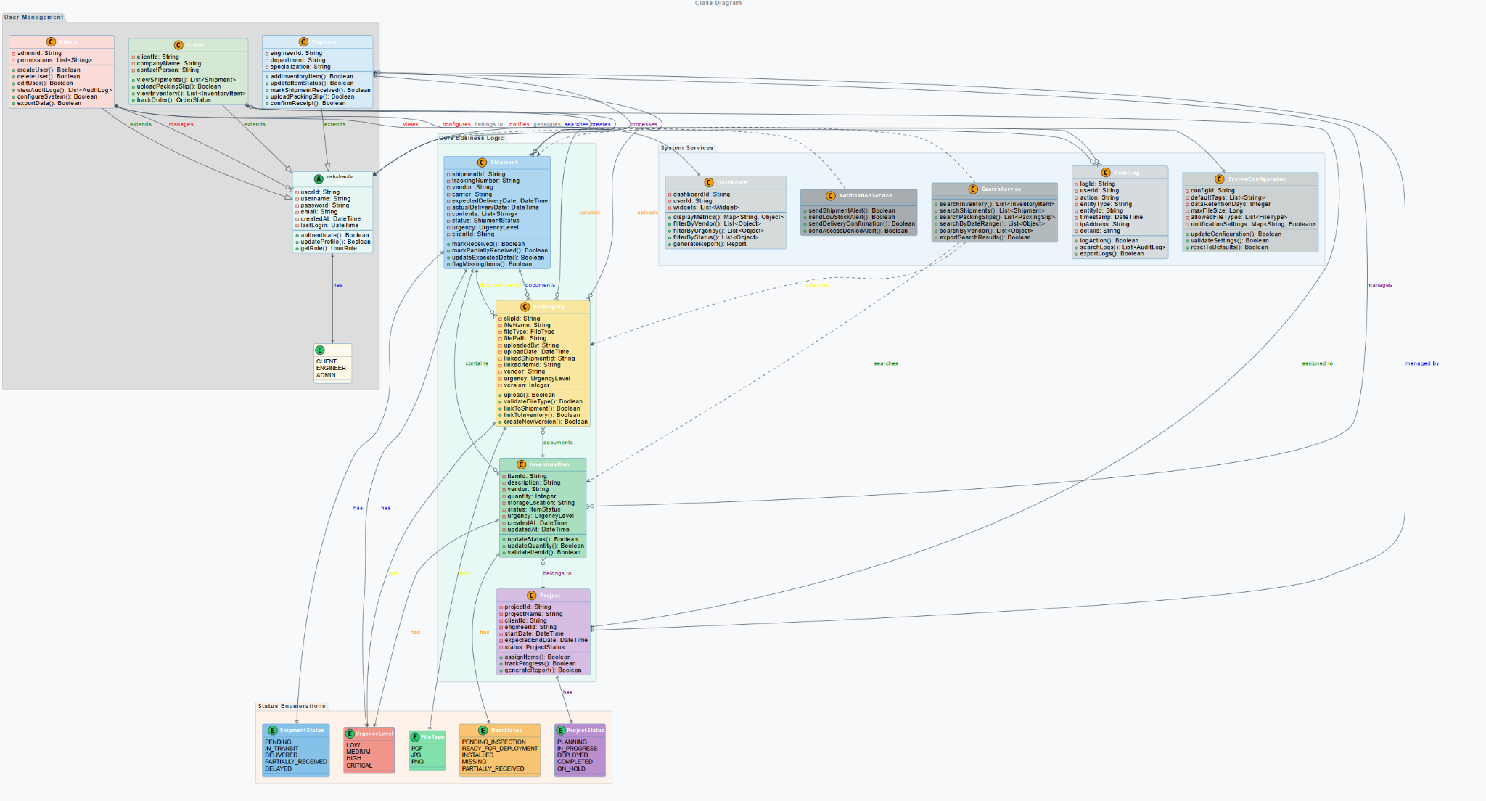

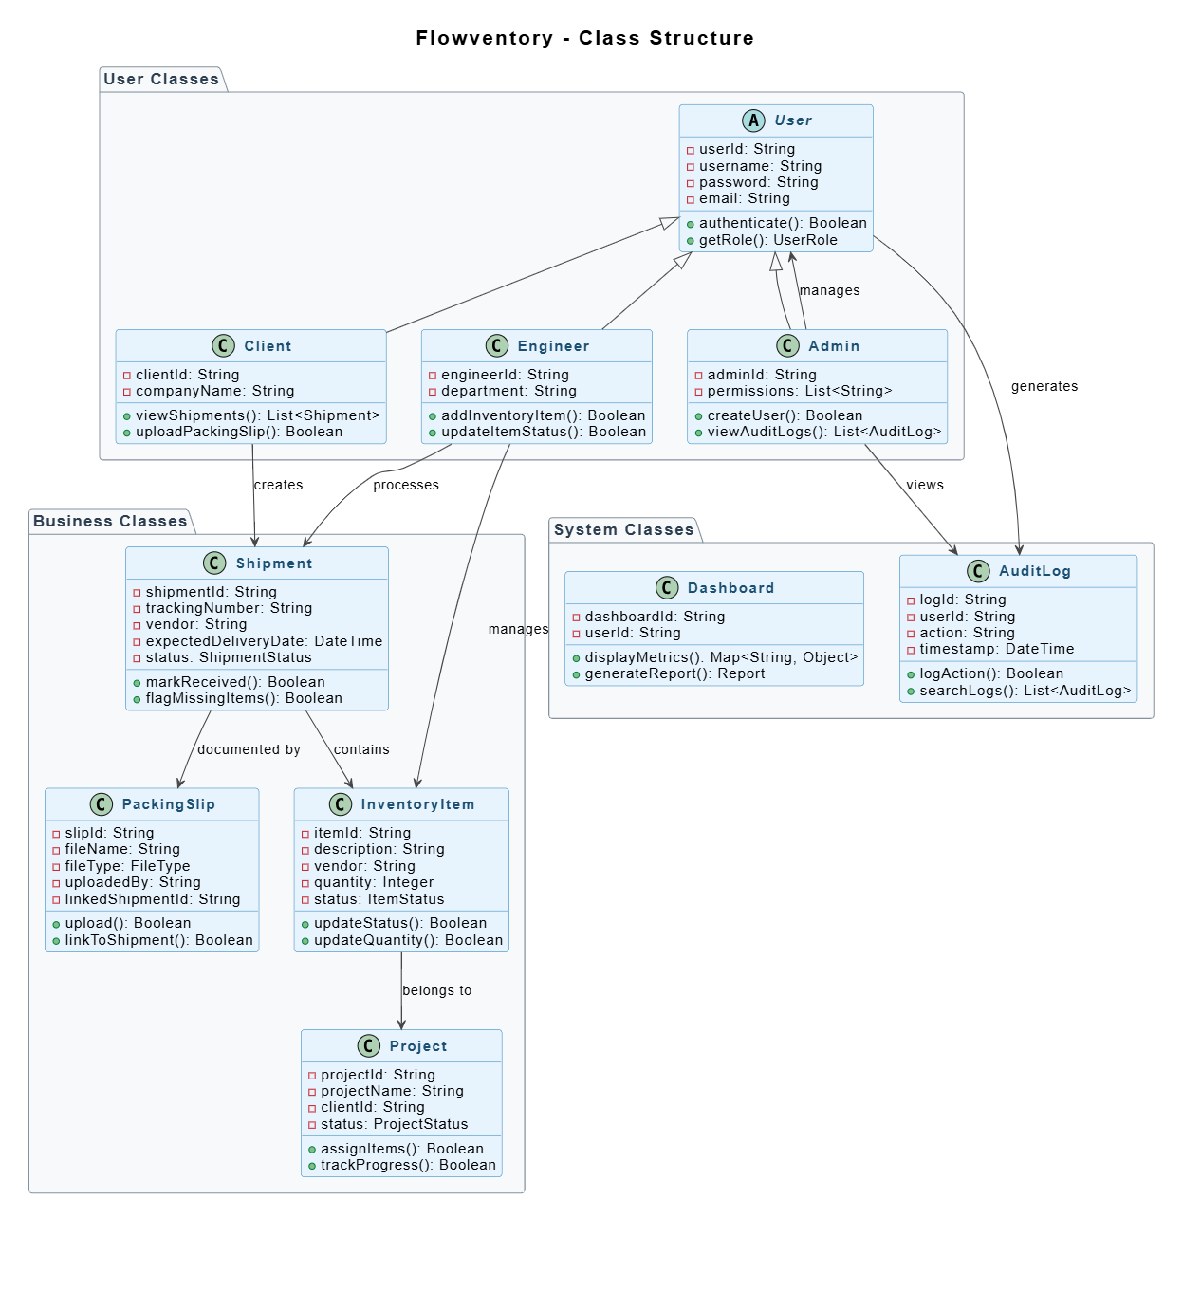
4.4 Communications Interfaces
Flowventory is designed to operate within a secure, containerized infrastructure. Core services (such as the backend and database) are hosted in an isolated Docker network to minimize external exposure, while the frontend is publicly accessible over HTTP/HTTPS via Cloudflare, using a reverse proxy, like Nginx.5. Other Nonfunctional Requirements
5.1 Security Requirements
The system shall identify users via username and password, and will allow selection of roles assigned to each user/pass pair.
5.2 Software Quality Attributes
5.2.1 Correctness
The system should make an effort to avoid collisions in shipping labels/IDs, and keep an accurate model of system state, regardless of inclement events like crashes or power outages.
5.2.2 Availability
The system should support more than 10 users and should be available for demo purposes.
5.2.3 Security
The system should ensure that data is only changed by accounts with proper permissions.
5.2.4 Portability
The web app should support any of the current major browsers (Firefox, Chrome, Safari).
5.2.5 Performance
The system should load webpages in under 4 seconds and respond to database queries within 500 ms.

6. Supporting Information
6.1 Development Phases

Feature | Phase | Task | Description | Technologies | Requirement
Order Tracking | Phase 1 | The manager can upload an order by filling out a form | Allow managers to be able to create an order by filling out a form | Python, HTML, SQL | REQ-INV
Order Tracking | Phase 1 | The manager can cancel an order | Allow managers to cancel an order they made | Python, HTML, SQL | REQ-INV
Order Tracking | Phase 1 | The manager can edit an uploaded order | Allow managers to make edits to certain aspects of the order (versioning exists) | Python, HTML, SQL | REQ-INV
Order Tracking | Phase 1 | Order Status update | Users can see the status of the order (Submitted -> in progress ->closed/canceled) | Python, HTML, SQL | REQ-INV
User Registry | Phase 1 | Create a user account | Create a user account as Manager or Engineer | Python, HTML, SQL | REQ-RBAC
User Registry | Phase 1 | Update user account | Update aspects of the user account. | Python, HTML, SQL | REQ-RBAC
Governance | Phase 1 | Accounts are assigned roles | Admins will assign roles to accounts, for example, Managers and Engineers | Python | REQ-RBAC
Order Tracking | Phase 2 | An engineer can create and add a packing slip for an order | When an order is fulfilled, the packing slip should be added to the order | Python, HTML, SQL | REQ-RBAC
Order Tracking | Phase 2 | An engineer can edit a packing slip | Engineers can modify certain aspects of the packing slip they added (versioning exists) | Python, HTML, SQL | REQ-RBAC
Order Archiving | Phase 2 | The user can search for packing slips and orders | Users can look up orders and their packing slips in a dashboard | Python, HTML, SQL | REQ-ARCH
Order Archiving | Phase 2 | The user can filter | by project, vendors, urgency, or status | Python, SQL | REQ-ARCH
Order Archiving | Phase 2 | The user can search by choosing tags. |  | Python, HTML | REQ-ARCH
Order Tracking | Phase 2 | Managers and Engineers can attach documents | Managers and Engineers can upload and attach documents to orders (packing slips, order descriptions, etc.) | Python, HTML, SQL | REQ-DOC
Governance | Phase 3 | Auditing | Application events are logged, and admins have access to view them | Python, SQL | REQ-AUDIT
Governance | Phase 3 | Versioning | Previous versions of orders that have been modified are going to be available as well | Python, HTML, SQL | REQ-VERS

6.2 Test Cases

Functionalities/Method | Input | Output | Pass/Fail
Users should be able to Log in to their respective accounts | Username and Password | Dashboard + access to website | Pass
Users should be able to Search keywords to filter in the inventory tab | Keyword/letters | Filtered results | Pass
Users should be able to add stock | Stock information | Item should appear in the inventory tab | Pass
Users should be able to choose an item to pick | Part number or SKU | After confirming pick, user should get confirmation and item quantity should change | Pass
Users should be able to create packing slips. | Filling form with packing slip information | Packing slip is recorded and stored. | Pass
Admin should be able to add user | User’s name, and page access | New user added to the system | Pass
Admin should be able to view, edit, and delete users | Updated information | User’s information updated | Pass
More detailed breakdown is available in the Github under
“DELIVERABLE_4_TEST_CASES.md”

6.2 Team Contributions

Member Name | Contribution Description | Overall Contribution | Note
Preet | Frontend | 20% | completed.
Carlota | Docker | 20% | completed.
Yana | Database | 20% | completed.
Dany | Backend | 20% | completed.
Jack | Documentation | 20% | completed.

7. Installation/Usage
7.1 Docker Installation (Recommended)
The entire application (frontend and backend) can be deployed using Docker with a single command. Prerequisites:
- Docker installed on your system
- Docker Compose installed
Steps:
- Navigate to the project root directory:
cd TRANSFORMERS-FLOWVENTORY
- Build and run the Docker container:
cd docker
docker-compose up -d
- Access the application:
Open your browser and navigate to: http://localhost:4000
- To stop the application:
docker-compose down
Note: The Dockerfile and docker-compose.yml are located in the docker folder. This single container setup includes both the frontend and backend services.

7.2 User Manual
Using the system as a Manager
- After logging in as a manager, you are met with a Dashboard tab
- You can view:
  - Total items (you ordered)
  - Items received
  - Pending shipments
  - Flagged issues
Using the system as an Engineer
- After logging in as an engineer, you are presented with the Dashboard tab
- You can view:
  - Total items (you ordered)
  - Items received
  - Pending shipments
  - Flagged issues
- Access to the Inventory tab:
  - Lists all shipments
  - Click on shipments to view more details
  - Shipment statuses: pending, received, or delayed
- Access to the Shipments tab:
  - View the same shipment list
  - Upload packing slips for shipments
Using the system as an Admin
- After logging in as an admin, you are presented with the Dashboard tab
- You can view:
  - Total items (you ordered)
  - Items received
  - Pending shipments
  - Flagged issues
- Access to the Inventory tab:
  - Lists all shipments
  - Click on shipments to view more details
  - Shipment statuses: pending, received, or delayed
- Access to the Shipments tab:
  - View all shipments
  - Upload packing slips
- Access to the Admin tab:
  - View all users with their roles, last login, and status
  - Create new users by clicking "Assign a new user" button
  - Assign roles to users

8. Code Inspection Feedback
During the peer code inspection session, our project was reviewed by Team 99 using the standardized inspection checklist. Overall, the reviewers noted that the codebase was clean, organized, and free of common issues such as uninitialized variables, null-pointer risks, improper typing, incorrect loop behavior, or dead code. They confirmed that class structures and inheritance were implemented correctly and that arithmetic, logic, and error-handling structures were clear.

Primary Feedback Noted:
The main issue identified during the inspection involved user ID assignment and reuse. In our current Phase-II implementation (prior to integrating the full database), user IDs were generated based on the length of the user list. As Team 99 pointed out, this could cause duplicate IDs when a user is deleted. For example:
- Start with Users 1, 2, and 3.
- Delete User #2.
Add a new user → the new user would incorrectly receive ID #3, resulting in duplicate entries.
The reviewers noted that this behavior could cause indexing inconsistencies in user management operations.

Actions Taken Based on Feedback:
- We confirmed the issue and updated our design to remove list-length–based ID assignment entirely.
- Since Phase-II fully integrates database storage, we resolved the problem by using PostgreSQL auto-incrementing primary keys, which guarantees globally unique, non-reusable user IDs.
- This approach also ensures that historical references (e.g., audit logs, versioning in Phase III) remain consistent even if users are removed.
- We documented the fix in the user management module and updated relevant backend endpoints to ensure IDs are always handled by the database rather than application logic.
Summary:
The feedback was valuable and directly influenced improvements to our user management system. While no other technical issues were identified in the inspection, this correction strengthens system reliability and prevents conflicts in future features that depend on unique identifiers.
9. Reflection
- What we've done
  - Frontend application is fully structured and functional
  - Backend is implemented with database integration
  - Docker deployment is fully implemented - entire application runs in a containerized environment
  - User interface includes proper warnings/popups for non-functional features
  - Role-based access control (RBAC) implemented for Admin, Manager, and Engineer roles
- What went well
  - Work was completed independently by team members
  - Successful Docker containerization for easy deployment
  - Clean separation between frontend and backend
  - Comprehensive user management system
- What could be improved
  - Consistency in team meetings and communication
  - Database optimization and performance tuning
  - Enhanced team communication and collaboration
  - Mobile responsiveness improvements
  - Additional automated testing coverage

